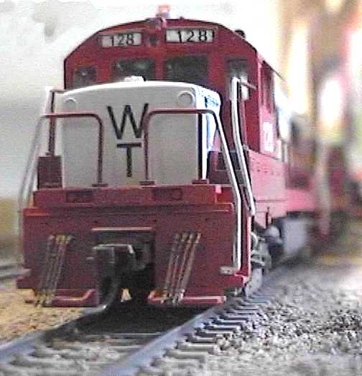
WESTPORT TERMINAL RR |  |  |  |  |  |  |  |  |  |  |  | FIRST DIVISION
Westward Trains |  |  |  |  |  |  | Time-Table |  |  |  |  | Capacity of sidings in 45 ft. cars exclusive of engine and caboose. | Station Numbers | Eastward Trains
 |  |  |  |  | Distance from South Jct. |  | No. 40 |  |  |  |  |  | Station Numbers
190 | 110 | 60 | 50 |  |  |  |  |  |  |  |  |  | Station Numbers | 58 | 61 | 65 | 111 | 191
Trans fer | Trans fer | RDC | Com muter |  |  |  | In effect Jul. 1, 2003 |  |  |  |  |  | Station Numbers | Com muter | RDC | RDC | Trans fer | Trans fer
Daily Except Sun. | Daily Except Sun. | Daily | Daily |  |  |  |  |  | STATIONS |  |  |  | Station Numbers | Daily | Daily | Daily | Daily Except Sun. | Daily Except Sun.
PM | AM | AM | AM |  |  |  |  |  |  |  |  |  |  | AM | AM | PM | AM | PM
....... | 8:05 | 10:10 | 7:50 |  | 0.0 |  | YL |  | INTERN.FALLS |  |  | yard | 1 | 7:10 | 11:55 | 4:10 | 9:30 | .......
....... | 8:20 | 10:20 | 8:00 |  | 17.0 |  |  |  |  |  |  |  |  | 7:00 | 11:45 | 4:00 | 9:10 | .......
 |  |  |  |  |  |  | YL |  | WESTPORT |  |  | yard | 2
2.55 | ....... | 10:30 | 8:10 |  | ... |  |  |  |  |  |  |  |  | 6:50 | 11:40 | 3:50 | ....... | 2:10
....... | ....... | 10:40 | ....... |  | ... |  |  |  | HARBOR JCT. |  |  |  |  | ....... | 11:30 | ....... | ....... | .......
3:10 | ....... | ....... | 8:25 |  | 25.5 |  | YL |  | SOUTH JCT. |  |  | yard | 3 | 6:30 | ....... | 3:55 | ....... | 1:55
0:15 | 0:15 | 0:20 | 0:35 |  |  |  |  |  | Scheduled time |  |  |  |  | 0:40 | 0:25 | 0:35 | 0:15 | 0:15
 |  |  |  |  |  |  |  |  | Average miles an hour
 | YARD LIMITS: |  |  |  |  | Branch Line: Third Street Distirct (300' west of Siding switch), to
 |  |  |  |  |  |  |  |  |  |  | Plywood District (300' east of Shop switch).
Within yard limits (indicated by yard limit signs and in the time-table), the main track may be used, clearing the time of first class trains at the next station where a time is shown.
Track Warrant
Basically you give them a warrant and move them to protect the schedule in the timetable.
Track Warrant: Clearance to a given section of track is granted by using a track warrant.
Before initiating movement on a main track, a crew member must receive a track warrant.
Make reverse movements on the main track at restricted speed and only within the limits a train has authority to occupy the track.
Within yard limits, trains or engines are authorized tu use the main track not protecting against other trains or engines. Engines must give way as soon as possible to trains as they approach.
An employee who requests a track warrant must inform the train dispatcher what movements will be made and, when necessary, which tracks will be used and how much time is required.
A track warrant is in effect until a crew member reports the train has cleared the limits, or the track warrant is made void. The crew member must inform the train dispatcher when the train has cleared the limits.

Westport Terminal RR

Just in time - and safe

Timetable No. 1

In Effect 12:01 AM, Friday, February 2, 2007

FOR THE ENJOYMENT OF EMPLOYEES ONLY

Quick Guide to Basic Operating Procedures

This pamphlet is intended to give you the basic information you need in order to run trains under the Track Warrant Control operation scheme in use on the FREMO meeting. It incorporates general TWC procedures, as well as ones specific to this layout.

Don’t forget:

TRAIN AND YARD AIR BRAKE TESTS

Type of operation | Initial terminal air test | Brake pipe leakage test | Rear-end set and release
Set out one or more cars | - | - | 2 min  with road engine
Pick up one or more cars | 1 min per car | - | 2 min  with road engine
Change engine and/or caboose | - | - | 2 min  with road engine
Initial terminal test with yard air | 2 min per car | 2 min | 2 min  with road engine
Initial terminal test with switch engine | 2 min per car | 2 min | 2 min  with road engine
Initial terminal test with road engine | 1 min per car | 2 min | Slow (5-10 mph) roll-by inspection

Vereinbarung
Der Betreiber schaut nach Norden, Osten ist rechts, Westen links. Alle Weichen sind ortsgestellt (mit Schubstange oder - in 3rd Street District teilweise - mit Motor. Ausnahme: Harbor Jct. und South Jct. Diese Weichen werden vom Tower / Dispatcher bedient.
In Westport werden die Hauptweichen vom Yardmaster elektrisch bedient

Am Regler
Sicherheit geht vor!
Die Glocke muß bedient werden bei
- Ankunft oder Abfahrt in einem yard
- Näherung an einen Bahnübergang oder eine Personenhaltestelle.
Das Horn / die Pfeife muß betätigt werden,
- bevor der Zug losfährt,
- bei Näherung an einen Bahnübergang oder eine Personenhaltestelle,
- vor einer Brücke oder einem Tunnel
- bei Näherung an einen anderen Zug.
Diesellokomotiven müssen im Gefälle dynamic brakes benutzen, falls vorhanden. Auf der FRED-Karte steht
die Belegung der Tasten. Üblich für F0 - Licht/sound, F1- Glocke, F2 - Horn/Pfeife

Geschwindigkeiten
In yard und Industriegebieten 10 mph, Ausnahme: Züge erster Klasse
Güterzüge 35 mph
Personenzüge 50 mph

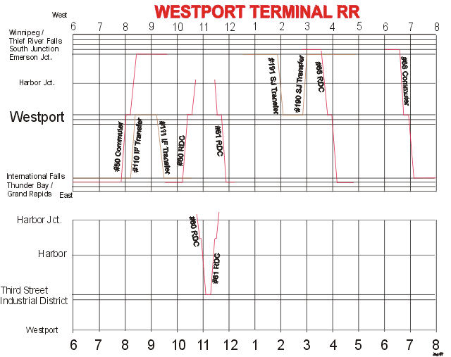
Ankuppeln: eine halbe Wagenlänge vor dem Wagen halten, dann mit weniger als 4mph ankuppeln. Entkuppeln: Entkuppler oder Magnet benutzen
Nicht die Fahrzeuge anfassen. Erst recht nicht auf das Dach greifen! (Höchstens an der Kupplung schieben/halten!)

Vor der Abfahrt: Bremssystem mit Luft füllen. Das dauert 5 „echte“ sec pro Wagen.
Gönne dem Personal Zeit zum Laufen zur Weiche, sie können nicht fliegen!

